CREATIVE WRITING & JOURNALISTIC PUBLICATIONS

Western Dubuque High School Course/Instructor Information
Course Number: 1220
Course Location: Room # 108
Instructors’ Names: | Mrs. Gretchen E. Kratochwill-Jones
School Email: | gretchen.kratochwill-jones@wdbqschools.org

Course Description and Outcomes
This course is designed to introduce students to the many forms of creative writing and journalism. During the course, students will gain experience with several forms of creative expression, such as poetry, drama, fiction, and nonfiction. Importance will be placed on proofreading and revision, voice and style, audience, and the use of literary elements. Students will also focus on the basic elements of journalism as they explore AP Style and their choice of news, feature, opinion, or sports. Other important components will include editing, interviewing, and basic research skills. Lastly, this course will submit articles to the Dyersville Commercial and Cascade Pioneer. Articles may also be submitted to the Bobcat Bulletin.

Required text(s)
There is not a required textbook for this particular course; however, various readings (both paper and online links) will be provided for you throughout the semester. In addition, you will be expected to utilize the Westerner Handbook, which has been created specifically for this course and your use in writing news articles/film reviews.

Western Dubuque High School Common Grading Scale
93-100 A
90-92 A-
87-89 B+
83-86 B
80-82 B-
77-79 C+
73-76 C
70-72 C-
67-69 D+
63-66 D
60-62 D-
59 and below F

Plagiarism Policy
Plagiarism is the submission of an academic assignment as one’s own work, which includes critical ideas or written narrative that are taken from another author without proper citation. This not only applies to direct quotes, but also to critical ideas that are paraphrased by the student.
Plagiarism includes but is not limited to:
- Submitting the work of others as your own
- Submitting others’ work as your own with only minor changes
- Submitting others’ work as your own without adequate footnotes, quotations, and other reference forms
- Multiple submission of the same work, written or oral, for more than one course without both instructor’s permission, or making minor revisions on work which has received credit and submitting it again as new work

As this is entirely a writing course, students who plagiarize an assignment will receive an automatic F.

Weighted Grading Categories
Grades will be weighted in various categories. The following displays the weighted scale on which a student’s overall grade will be based:
Creative Writing | 45%
Newswriting  Participation/Peer Review | 15%  10%
Final Portfolio | 30%

Additional Course Requirements
FINAL PORTFOLIO – Please save and keep track of ALL writing projects. You will make selections from ALL of this work to create your final portfolio. This portfolio will need to contain your TWO original and edited journalistic pieces (a newspaper article and one film review) and THREE original and edited creative pieces. Thus, your portfolio will contain a total of TEN pieces, five originals and five polished pieces. In addition to selecting works that showcase your writing abilities, you may wish to choose those that best reflect your progress in this course. More information about the portfolio will be discussed in class as we near the end of the trimester.

FREEWRITES/JOURNALS – During this class, we will spend some time freewriting or journaling in notebooks with various
writing prompts to prepare you for an upcoming assignment or simply to explore an idea or a type of writing. From time to
time, I may collect one or more of these freewrites to assess your writing. Points distributed for these freewrites will be
weighed within the “Participation/Peer Review” category above.

ABSENCES AND MAKE-UP WORK – If you are absent, it will be 100% your responsibility to make up any missed work.
Please pick up and complete this work in a timely manner. Work that remains incomplete for an extended period of time
(depending on the reason and length of your absence and the discretion of your instructor) will receive an F. In addition, if a
student is not in attendance on a deadline day or due date, he or she is expected to notify me prior to the absence or contact
me by email (unless it is, of course, an emergency). If this is not done, the student’s work will be counted as late. Lastly, late
work will lose points for each day it is not turned in; the number of points lost each day will depend on the assignment’s total
points.

PARTICIPATION – In addition to attending class, you are expected to participate. Participation does not only include
answering questions and contributing to discussion; it also includes respecting your classmates, your instructor(s), and yourself.
Causing a disruption or making insensitive comments will not be tolerated.

CELL PHONES – Students are not to have their cell phones during class unless permission is granted. The school’s policy
suggests that if I see or hear your phone, it should be confiscated. A second violator’s phone will be sent to the office.
Basically, put it away and WRITE! Do not waste your in-class work time!

“Words - so innocent and powerless as they are, as standing in a dictionary, how potent for good and evil they become in the hands of one who knows how to combine them.” —Nathaniel Hawthorne

Tentative Course Schedule
Note: This course schedule is subject to change at any time.
Introduction to the course: Syllabus, assignment options, etc.
Introductory Assignment – Personal Profile
Poetry and Workshopping
-Complete 2 different poems
Fiction
-Complete children’s story
Fiction 1-2 projects
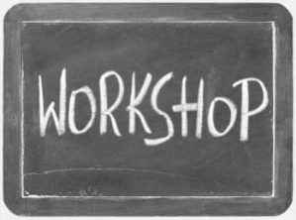
Newspaper Introduction - Nonfiction
-Complete news article # 1
Nonfiction 1-2 projects
Writing an AP-Style Film Review or news article # 2
-Personification
**FINAL PORTFOLIOS**
-Calligraphy?
-Group writes

Creative Writing and Journalistic Publications Common Assessment

~Final Portfolio Checklist and Grading Rubric~
 | Content of Portfolio |  | Other Grading Criteria
__/2 | Genre of Piece: __________________________  Creative Writing Piece # 1 – Rough Draft  *Areas that are changed in the final copy must be highlighted or set off in some manner. | __/2  __/4 | Overall Neatness  Table of Contents/Clear Organizational Format
__/4 | Creative Writing Piece # 1 – Polished Draft  Genre of Piece: _________________________ | __/4  __/2 | Cover Page (Proper MLA Information)  Overall Creativity
__/2 | Creative Writing Piece # 2 – Rough Draft  *Areas that are changed in the final copy must be highlighted or set off in some manner. | __/12
__/4 | Creative Writing Piece # 2 – Polished Draft  Genre of Piece: __________________________ |  | Letter to the Instructor
__/2 | Creative Writing Piece # 3 – Rough Draft  *Areas that are changed in the final copy must be highlighted or set off in some manner. | __/4 | Proper Letter Format
__/4 | Creative Writing Piece # 3 – Polished Draft  Assignment Title: ___________________ | __/5 | Discusses At Least TWO SPECIFIC Examples of Student’s Improvement as a Writer
__/2 | Newswriting Piece # 1 – Rough Draft  *Areas that are changed in the final copy must be highlighted or set off in some manner. You will also need to include a short reflection. | __/4 | Answers the Question: What Have You Learned?
__/4 | Newswriting Piece # 1 – Published Version  Assignment Title: ___________________ | __/5 | Correct Spelling, Grammar, and Mechanics
__/2 | Newswriting Piece # 2 – Rough Draft  *Areas that are changed in the final copy must be highlighted or set off in some manner. You will also need to include a short reflection. | __/18
__/4 | Newswriting Piece # 2 – Published Version  Overall Comments:
__/30 |  | FINAL PORTFOLIO TOTAL = ___/60

Final Portfolio Guidelines:

- You must choose THREE creative pieces from this course (any piece that you wrote in this class---freewrites, children’s stories, poems, or any formal piece); however, you may only use one poem/one freewrite at most. This is because I want to see the revisions to your writing based upon critiques from your peers and my comments. More importantly, this will also allow me to see the development of your writing in a longer piece.)

- You must choose TWO journalistic pieces from this course. For most of you, this only includes your article and your final film review. If you have written more than one article, you should choose what was completed to the best of your ability.

  - After selecting these pieces, you will need to revise! You MUST highlight changes that you made on the new and revised copy.

  - For newswriting pieces, you will need to print the published version (if possible) and note the changes that were made with a highlighter on the published copy. You will also need to write a sentence or two reflecting on why certain changes were made to your article to improve it. If you do not have a published version of your article(s)/film review, you will need to make corrections in Microsoft Word and then highlight the changes on the new and revised copy, as you will do for each of the creative pieces in your portfolio. Finally, do not forget to write a sentence or two about why certain changes were made to improve the piece.

- Like any professional portfolio, your portfolio should look neat and be well organized. You need a cover page, a table of contents, and, of course, to be creative with your thematic layout.

- Lastly, you need to write me a formal letter addressing the following: What have you learned about creative writing or journalism? Cite AT LEAST two specific examples concerning your growth as a writer. Also, what was your favorite assignment? Why? Make sure you use proper letter format in this piece and that your mechanics, grammar, and spelling are correct!

- Good luck!
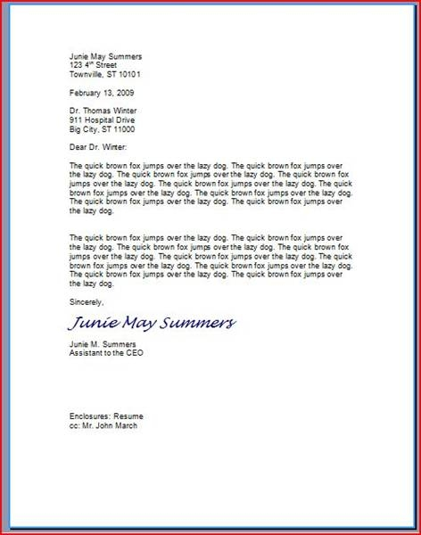

This letter does not say anything

important, but it shows you the

proper format for a professional

letter. You must single space your

paragraphs and left align all of

your text. Do not indent for new

paragraphs.

Also, the top will say your name and address. Then,

your recipient’s information will be beneath the date.

I am your recipient for this, and my information is

as follows:

Mrs. Gretchen E. Kratochwill-Jones

English Instructor

Western Dubuque High School

302 5th Ave. SW, PO Box 379

Epworth, IA 52045

If you have any questions, please let me know!

